MoonLite High Resolution Stepper Motor

MoonLite’s high resolution stepper motor option comes in three configurations.

* Stepper motor only or “stand alone” for $190.00 (customer provides controller)
* Stepper motor with MoonLite Mini V2 Controller for $440.00 (mini V2 controller by itself is $250.00)
* Stepper motor with MoonLite Dual Port DRO Display Focus Controller for $685.00 (controller by itself is $495.00)

MoonLite’s high resolution stepper motor options use a premium, low backlash Hurst stepper motor. This provides very fine .00016” resolution (full step) and accurate position repeatability required for today’s high end imaging systems. The stepper motor can also be ran in half step mode providing .00008” resolution, but it is recommended to run in full step mode with most ASCOM software. The high resolution stepper motor is offered on all single rate focuser configurations. It has such a fine variable rate that the reduction unit is not needed, so it is not offered on dual rate focusers. Adding a stepper motor gives the CS and CF focusers a 7 lb. lifting capacity, large format focusers such as the CRL, CSL, and CFL are rated at 8 lb. vertical lifting capacity, and CR model focusers a 6 lb. load rating once installed. The stepper motor option features an adjustable slip clutch system so the focuser can be used manually or operated on motor at the same time. The stepper motor’s 9-pin DBA connector is compatible with other stepper motor controllers such as ROBO focus, as well as MoonLite’s controllers. A controller of some type must be used; the stepper motor cannot be directly connected to a PC. The DB9 connector on the motor is not a serial port, it handles motor winding voltages.

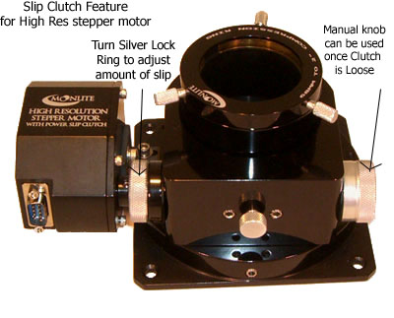

The amount of slip can be adjusted on the slip clutch by adjusting the tightness of the slip clutch ring. For manual knob operation of the focuser, turn the silver knurled ring loose. For motor operation of the focuser, tighten the silver knurled ring. To adjust the knurled rings tension, it helps to hold the manual knob still with your right hand and turn the clutch ring with your left hand. Holding the manual knob in place will keep the shaft from turning, allowing the clutch ring to tighten/loosen the clutch ( Think of the adjustment like taking the lid off a jar, twist tight loose) Note: No damage will be done if the focuser motor continues to run past the mechanical stops of the drawtubes travel. Even if the clutch is tight, it will simply slip when the travel runs out.

In most cases, the stepper motor option is picked at the time of purchase; however, we do offer a user installed kit for existing MoonLite focusers. The kit comes with different mounting brackets to fit MoonLite focuser models. Please see our web site for additional kit information showing the brackets available for different model MoonLite focusers.

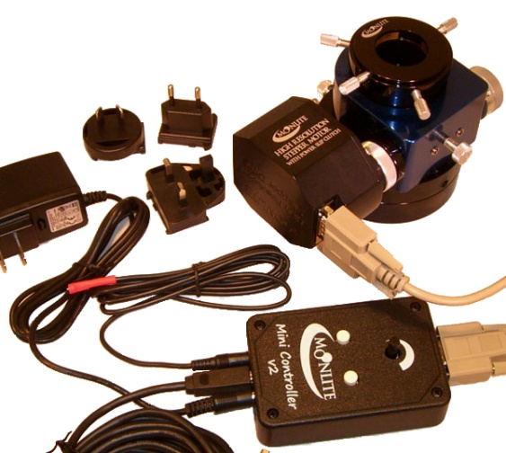

* The high resolution stepper motor only or **stand alone option** is for customers that already have a ROBO focus controller or other brand controller and do not need a controller. The stepper motor’s DB9 connector pin out is 100% compatible with the ROBO focus controller.
* The high resolution stepper motor with **MoonLite Mini V2 controller** uses an ASCOM compliant stepper motor controller from MoonLite. The “Mini V2” controller works with all ASCOM based software packages such as Focus Max, CCDSoft, MaximDL, etc. It features a built in temp sensor and also comes with a remote temp probe. We include a USB cable and 12 volt DC -AC adapter that has all the different plug configurations (US, Europe, UK, and Australia); however, most customers will simply use 12-volt DC power off their mount. This mini V2 controller is designed to be used remotely by a PC, or by the up /down buttons and speed control knob on the controller. It has all the functions of our larger DRO display controller but no display. Our ASCOM drivers and apps can be downloaded from our site.
* 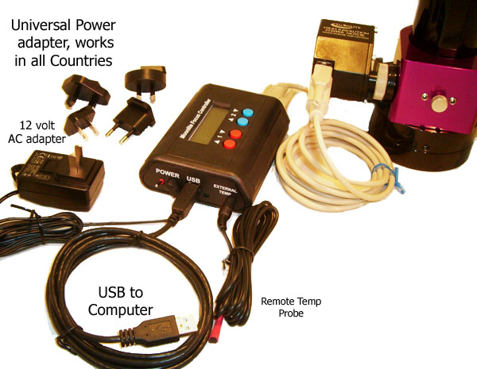The high resolution stepper motor with **MoonLite’s Dual Port DRO Display Focus Controller** can operate 2 high resolution stepper motors at the same time. Normally motor port #1 is for our existing high resolution stepper motor for focusing and motor Port #2 is for rotator stepper motor system. It can also operate 2 different focusers at the same time without a rotator. This controller will be able to provide a complete 2 axis automated setup. The controller operates just like the Mini controller above, but has a display to show position. It also comes with a remote temp probe.

**Connection**

MoonLite provides a 6 foot 9 pin DBA serial cable to go from the controller to the high resolution stepper motor on the focuser. The cable looks like a serial cable; however, the signals from the controller to the motor windings are not computer signals. We use the first 5 pins in the cable to power the stepper motors windings. Extra-long (25’) serial cables are available if needed. Two cables are included with the dual port DRO display controller for future use with the flange rotator option.

A universal AC adapter is included with all controllers that will operate in different countries’ power (install the matching plug style in the 12 volt AC adapter you require). The power jack on the controllers is a typical 5.5mm OD by 2.1mm ID barrel jack with the center pin being positive. Power consumption is a low .15 amps with 1 motor running, and much less when idle. We include a 6 foot USB cable with the controller. Some customers use a USB hub for long distance runs. A remote temp probe can be plugged into the controller to bypass the built in temp probe located inside the case. Once plugged in, it will defeat the internal temp sensor. The probe can be taped to the side of the telescope for better thermal reading of the OTA.

**Basic Operation for the Dual Port DRO Display Controller**

First connect all cables and power up the controller using the power switch on the left side (Please note the boot sequence):

* The Display will go from Red, Green, and Blue.
* Then display “MoonLite Telescope” and the version of the software “Ver 23”.
* It will then give a message “Press a button to enter menu”. Do not press any keys during that time, so the controller can go into normal operation. If you press a button at that time it will go into advanced menu mode.

To get out of advanced menu mode – just cycle the power off and back on.

Top line of display shows step count position for focus motor on port #1

Bottom line of display shows step count position for rotator motor on port #2

Right side of display will show the temp detected by either the internal or remote external temp probe.

Red buttons will increase / decrease the focuser’s position (rack in / rack out).

Blue buttons will rotate the focuser, either right or left.

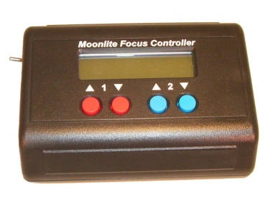The focus steps are fine and slow when the button is first pressed, but will go faster if the button is held down. Please remember to rack the focuser the whole way in to zero the step count to the focusers fully racked in position (hold the button down until the focuser is fully racked in. No harm will come to the focuser, as it will simply slip when hitting the mechanical stops). You can zero the display count by pressing both up and down buttons at the same time.

**Advanced Menu Operation for the Dual Port DRO display controller**

Press any key when prompted after unit is turned on.

**Setup Menu Structure:**

Contrast Adjustment: Used to adjust the LCD contrast.

Red Brightness: The brightness of the RED LED backlight.

Green Brightness: The brightness of the GREEN LED backlight.

Blue Brightness: The brightness of the BLUE LED backlight.

Motor 1 Type: Selects Unipolar or Bipolar. (Bipolar is not supported at this time)

Motor 1 Direction: Selects the which way results in positive step counts.

Motor 1 Half/Full: Selects if Motor 1 is Half stepped or full stepped. Half has double the resolution, but half the speed. Focus curve will need to be re-run if this is changed.

Motor 1 Units: The unit text to display. Steps or Degrees (for rotation).

Motor 2 Type: Selects Unipolar or Bipolar. (Bipolar is not supported at this time)

Motor 2 Direction: Selects the which way results in positive step counts.

Motor 2 Half/Full: Selects if Motor 2 is Half stepped or full stepped. Half has double the resolution, but half the speed. Focus curve will need to be re-run if this is changed.

Motor 2 Units: The unit text to display. Steps or Degrees (for rotation).

Home Switch: Select which motor has the optional home switch. Used for zero setting to a known point.

Temp Offset: Used to set the temperature offset for single point temperature calibration.

Temp Scale: Used to change the scaling to allow for two point calibration.

Reset To Defaults: Resets all of the above settings to the factory defaults. Activate by pressing both Blue Buttons at the same time.

DONE? Exits the setup menu and saves all settings to EEPROM. If a mistake was made, simply cycle power without exiting, or use the “Reset to Defaults” option.

**Expanded Commands:**

|  |  |  |
| --- | --- | --- |
| **Command** | **Response** | **Description** |
| POxx |  | Adjust Temperature Offset, Signed Hexadecimal |
| PSxx |  | Adjust Temperature Scale, Signed Hexadecimal |
| PRxx |  | Adjust Red Backlight Brightness |
| PGxx |  | Adjust Green Backlight Brightness |
| PBxx |  | Adjust Blue Backlight Brightness |
| PCxx |  | Adjust LCD Contrast |
| PXxxxx |  | Adjust the Scale for Motor 1 |
| Pyxxxx |  | Adjust the Scale for Motor 2 |
| PHxx |  | Find home for Motor, valid options are “01”, “02” |

The scale factor allows for stepped or scaled moves. If you have a filter wheel with a known 532 steps between positions, you can set the scale factor to 532d or 0x0214. Every button press would then move 532 steps. Remote commands remain unaffected by the scale.

The commands remain backward compatible with the original DRO focus controller, but now add a second channel, remote temperature sense, option home switch, and an improve user interface.

The motor move buttons are dual function. When pressed for a short time, they move the motor in very fine increments at a slow speed. When held down for longer periods of time, the motor speed picks up and fast moves are made.

**Serial Commands:** All commands are preceded by a “:” symbol and finished with a “#” symbol. “x” represents a hexadecimal digit.

|  |  |  |
| --- | --- | --- |
| **Command** | **Response** | **Description** |
| GP | XXXX | #Get Current Motor 1 Positon, Unsigned Hexadecimal |
| GN | XXXX | #Get the New Motor 1 Position, Unsigned Hexadecimal |
| GT | XXXX | #Get the Current Temperature, Signed Hexadecimal |
| GD | XX | #Get the Motor 1 speed, valid options are “02, 04, 08, 10, 20” |
| GH | XX | #“FF” if half step is set, otherwise “00” |
| GI | XX | #“01” if the motor is moving, otherwise “00” |
|  |  |  |
| GB | XX | #The current RED Led Backlight value, Unsigned Hexadecimal |
| GV | XX | #Code for current firmware version |
|  |  |  |
| SPxxxx |  | #Set the Current Motor 1 Position, Unsigned Hexadecimal |
| SNxxxx |  | #Set the New Motor 1 Position, Unsigned Hexadecimal |
| SF |  | #Set Motor 1 to Full Step |
| SH |  | #Set Motor 1 to Half Step |
| SDxx |  | #Set the Motor 1 speed, valid options are “02, 04, 08, 10, 20” |
|  |  |  |
| FG |  | Start a Motor 1 move, moves the motor to the New Position. |
| FQ |  | Halt Motor 1 move, position is retained, motor is stopped. |

Example: To set a new position: :SN0537#

*For motor 2 all of the above commands are available, just precede the command with a “2”.*

Motor 2 Example: To set Motor 2 to a new position: :2SN0537#

**MoonLite Mini V2 Controller Layout**

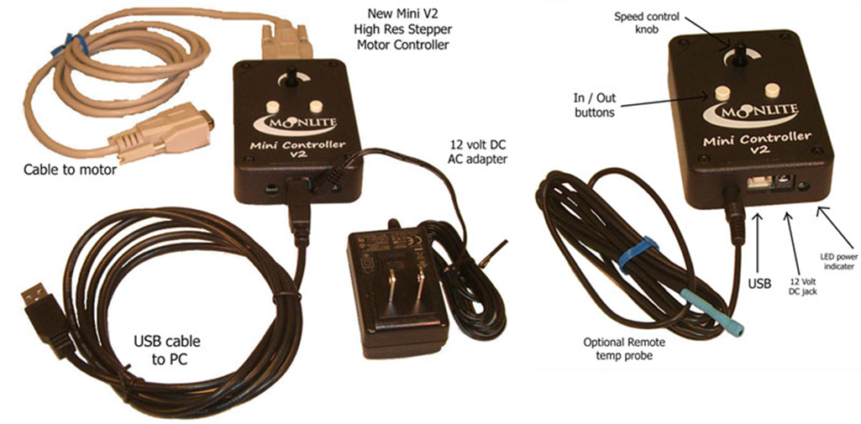Please note the internal temp sensor will be used if no remote temp probe cable is plugged into the controller. Once the remote temp probe is plugged in the controller it will not use the internal unit. Manual buttons will override and move the focusers position reported in the software. The speed control knob can go from no movement at all (full CCW) to a moderate rate (full CW) setting. Re-zero focuser step count by racking the drawtube the whole way down into a fully racked in position and also zero the count in the software to match.

Please see our down load page for all software at --- <http://focuser.com/downloads.php>

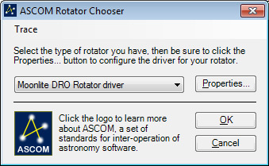

MoonLite offers a universal ASCOM driver that works with all Moonlite Mini V2 and Dual port DRO display controllers. The ASCOM driver works with a single focuser, dual focusers, and a focuser with both motors for focus and rotation. All ASCOM based software packages such as Focus Max, CCDSoft, MaxumDL, Sequence Generator Pro, Equinox Pro, are supported.

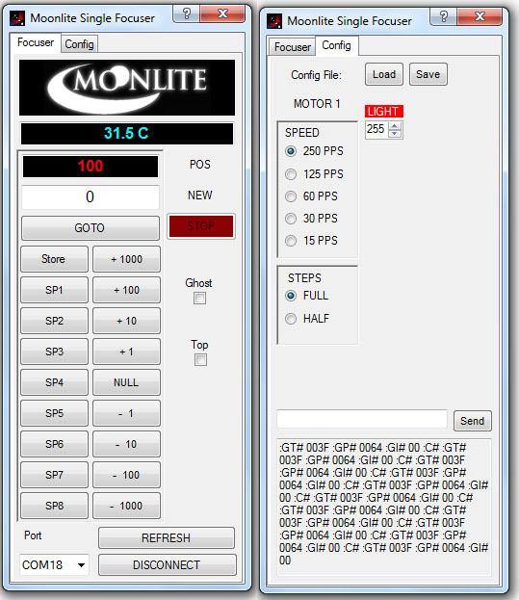

We also offer 3 simple non-ASCOM programs for customers not running ASCOM. Single focuser, Dual focuser, and Dual Rotator.

MoonLite’s single focuser 2.2.0.0 NON-ASCOM software program (photo at right) will work with all MoonLite single port controllers. The original Mini controller, new Mini V2 controller, and the original DRO display controller.

The latest version of the software has 5 user defined buttons for customers to store step count positions that are frequently used. Just go to the step count you want and then click Store and the SP button you want to assign the step count value to. Once finished with storing all 5 button values click Save and then pick a directory to save the info.

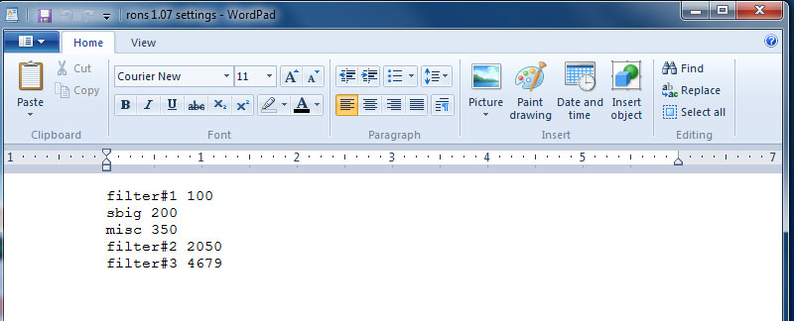

In this case I saved the file to a directory called camera positions. Once saved, I can then open the file in Word Pad and modify the text for the 5 buttons to label them anything that is required. Note: the old SP1 button now says filter#1 and will go to a step count of 100 if clicked. Then when I hit Load and indicate the file, it will now rename all of the buttons.

**MoonLite Non ASCOM Software Install Guide and Operation**

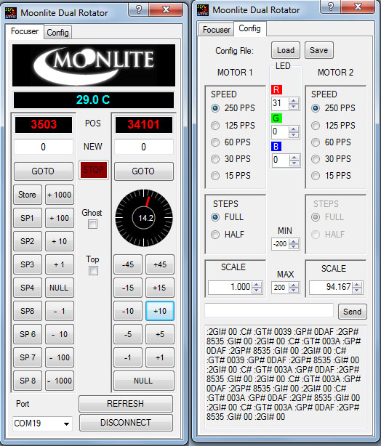

MoonLite’s Non ASCOM based programs are designed to provide PC based automation of both focus and rotator capability of your MoonLite Focuser equipped with either a Mini V2 controller or a Dual Port DRO display controller. No ASCOM is required but Microsoft .NET Framework 4 is required for the installation. This install procedure is the same for all MoonLite non ASCOM software, we will show the rotator version here as an example. Our MoonLite non ASCOM software works with all Win software OS such as XP, Win 7, and Win8 systems.

Download Focuser Setup.zip and extract the files to the default folder it requires. Please note the PC should have internet connectivity for any updates windows may need to perform during the installation. Be sure to uninstall the older FocuserNA1.07 program before installing this new FCP 2.107 version. Go to Control Panel, then Programs, then Programs and Features to remove the original program. Both programs can’t be installed on the same PC at the same time.

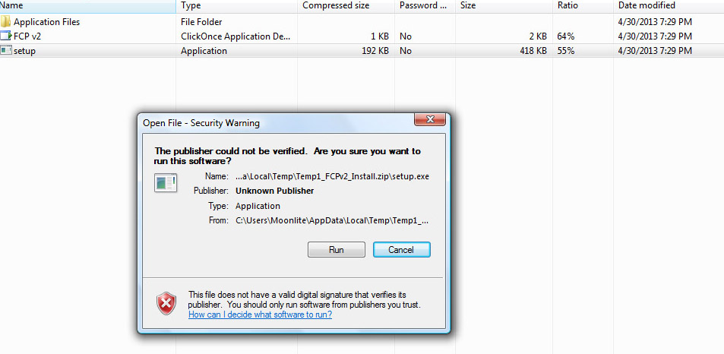Before running Setup, ensure that you have Microsoft .NET Framework 4 installed on your machine. This can be verified via: Control Panel/Add or Remove Programs. If Microsoft .NET Framework 4 is not installed on your machine, you can download it here: <http://www.microsoft.com/downloads/en/details.aspx?FamilyID=9cfb2d51-5ff4-4491-b0e5-b386f32c0992&displaylang=en> . Windows will access the web and update Net framework automatically if needed once you start installation. Next, verify your controller is connected to your PC and turned on. Click on the Zip file to start the installation See our download page at- http://focuser.com/downloads.php

Run "Setup”: Be patient, the program will verify that you have the correct .NET Framework and will populate a list of Com Ports in use.

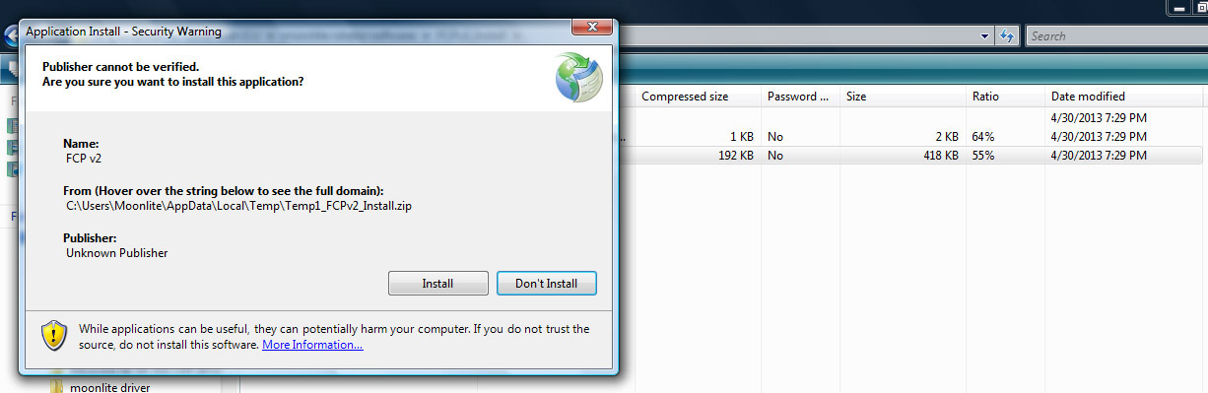

Continue with the installation and the program will launch.

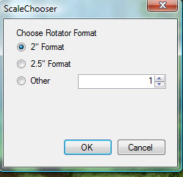

Pick the focuser format size you have. This will set the resolution scale in the software to the correct value.

The Focuser program will start up. Click the connect button to activate to the controller.

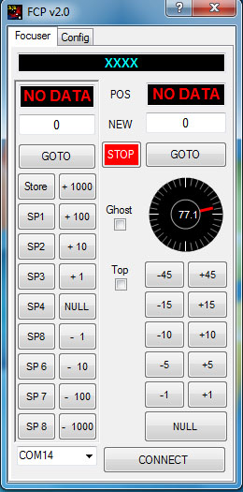

If an error message pops up like below, then check the com port setting in the lower left corner. The controller may be assigned to a higher number port.

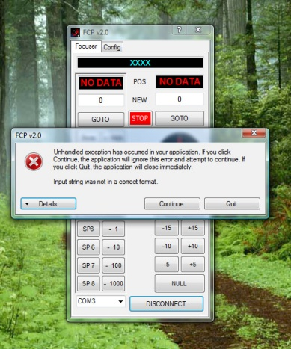

If it still will not connect, then check to make sure your PC has the correct USB driver. If your laptop is older, you may need to install the latest USB driver. To install the driver download the VCP (virtual com port) driver for the FT232R chip from <http://www.ftdichip.com/Drivers/VCP.htm> Unzip using your favorite zip file utility to a directory of your choice. Connect power to the focus controller and the USB cable to your computer and the focus controller. Windows will state that it has found new hardware and needs to install drivers. When prompted, select “Have Disk” and select the directory where the files were unzipped. The installer should then complete the software installation.

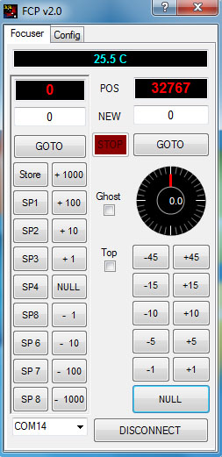**Operation for Dual Rotator Software Version:**

Left side is for focus, Right side is for rotation. Step count is displayed in red for both Focus and Rotation position. Manual values can be entered in the “White box”, then click GOTO to move to that position. Up to Eight focus positions can be stored in the SP buttons; however, the value must not be zero. The “Null” button on the left focus side will zero the count to the current position. Normally, the focuser is in the fully racked down position before “Null” is pressed. The controller will not allow a negative step count, so be sure to “Null” the position after racking the focuser the whole way down. The step count will increase in a positive value as the focuser racks up from the fully down position. The step count will be about 6250 steps per inch in full step mode. Focus position can be racked up / down by manually entering any step count value and clicking GOTO button. Focus position can also be moved by clicking the +1 button, +10 button etc. Please note all step count values must be between 0 and 65534, that is the limit range set in the controller. The Null button on the Rotator side will set the step count to 32767. This is the midway point in the step count range and allows CCW rotation down to 0 step count, and CW rotation up to 65534 step count. Your focuser and cables should be oriented in a level mid position before hitting the “Null” Button to set the midpoint. Once the focuser is level and the null button is clicked the software will set the degrees to zero. The focuser can now be rotated to any position from 0 to 360 degrees in .01 resolutions. Angle positions can be entered manually by entering the degree number in the white box then click GOTO. The rotation angle buttons 1degree, 5 degree; etc. can also be used for quick moves. Cable management limits will stop the focuser from rotating past 200 degrees in either direction.. A message will come up saying “Mechanical Limit reached”. Please note you may see the “Mechanical limit reached” warning when first connecting the controller to the software and focuser. It is due to the focuser not being nulled yet and is trying to move to random position in memory. If this happens and the focuser starts to move during first installation, then just click the stop button to stop it and then “null” the position. The controller will remember its position after everything is nulled for the first time, even when power is restored. The Configuration tab will allow settings to be adjusted by the customer.

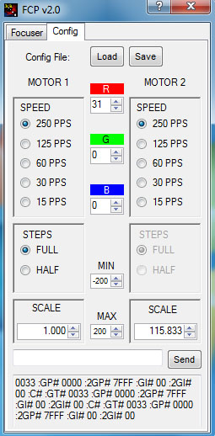The scale setting on the bottom right for rotation should be 94.167 for 2” format focusers and 115.833 for 2.5” large format focusers. This value represents steps per degree and can be changed if needed. Please note full step mode is the only supported mode for the rotation side. Half step mode is not allowed and is grey out.

Speed on both the focus side and rotator side can be adjusted from full speed at 250 down to 15. Both sides should be set to 250 as this allows the focuser to move at it fastest pace. There is no practical reason to slow down the controller moving the focuser, so please leave the setting at 250. A lower setting will just increase the delay or time between steps which in turn makes the moves appear slower.

The display color and brightness on the controller can be adjusted using the RGB buttons. Load and save buttons are for saving SP button focus positions and renaming the buttons on the focus side. Cable management limits can be changed by the customer from the default of 200 degrees in both directions. The Value can only be decreased not increased beyond 200 as that is the upper limit in the software. Please do not set cable management angle limits less than 180 degrees. This can cause the focuser not to be allowed to rotate to all 360 degree locations.

**Trouble Shooting**

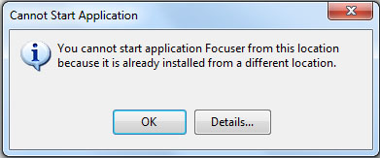If the software will not install, then Net frame is either an old version or not on the PC. Please make sure the PC has internet connectivity to allow Net frames to update and install correctly. If you get error messages when attempting to install the new software, be sure to uninstall any old MoonLite software first (it may be under the name FCP). Go to Control Panel, then Programs, then Programs and Features to remove the original program. Then return to installing the new MoonLite software. Only one program can be installed on a PC at a time.

If the controller will not connect, make sure your PC has an updated USB driver. All controllers require a modern Uart driver to connect to the PC using the USB port. If you are using an older PC or it is not connecting, please download the latest drivers from: <http://www.ftdichip.com/Drivers/VCP.htm>

If it times out trying to connect, select a different com port (Devise manager can help show port assignments) or download the driver noted above.

Serial communications traffic between the software and the controller can be seen in the bottom serial data log traffic box when in the configuration tab. This can be helpful for trouble shooting or verifying operation. Customers can also send raw commands directly to the controller from the software. This can be helpful if temperature calibration needs adjusted. Temp value offsets can be sent to the controller to adjust the displayed temp value up or down.

Example if you want to adjust/ calibrate the temp display, just type in PO02 in in the box and hit send. This will change the temp offset positive by 1 degree. A PO04 command would adjust it by 2 degrees. A POFC command would adjust it -2 degrees. All serial commands are in Hex. Please see serial command list in the High res stepper motor document for a complete list of serial commands.

**DB9 cable pin out and Stepper Motor winding pin out.**

We use a high quality Hurst unipolar 12 volt stepper motor with a fairly high reduction gearbox. There is a very small amount of backlash noted with this unit. MoonLite controllers will release idle current to the motor windings when not moving to reduce current consumption and also reduce heat generated by the motor itself. Some controllers like ROBO focuser and others will keep the current draw continuous when not in motion. That can cause the motor to get warm; however, it will not damage the motor.

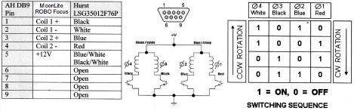

**Generic serial commands can be used to operate the controllers. Please see table below for command set.**

**Serial Commands**

|  |  |  |  |  |  |  |  |  |  |  |
| --- | --- | --- | --- | --- | --- | --- | --- | --- | --- | --- |
| **Command** | | | | | | | |  | **Return** | **Comments** |
| **Char #** | | | | | | | |  | **Variable** |  |
| **1** | **2** | **3** | **4** | **5** | **6** | **7** | **8** |  |  |  |
| **:** | **C** | **#** |  |  |  |  |  |  | **N/A** | **Initiate a temperature conversion; the conversion process takes a maximum of 750 milliseconds. The value returned by the :GT# command will not be valid until the conversion process completes.** |
| **:** | **F** | **G** | **#** |  |  |  |  |  | **N/A** | **Go to the new position as set by the ":SNYYYY#" command.** |
| **:** | **F** | **Q** | **#** |  |  |  |  |  | **N/A** | **Immediately stop any focus motor movement.** |
| **:** | **G** | **C** | **#** |  |  |  |  |  | **XX#** | **Returns the temperature coefficient where XX is a two-digit signed (2’s complement) hex number.** |
| **:** | **G** | **D** | **#** |  |  |  |  |  | **XX#** | **Returns the current stepping delay where XX is a two-digit unsigned hex number. See the :SD# command for a list of possible return values.** |
| **:** | **G** | **H** | **#** |  |  |  |  |  | **00# OR FF#** | **Returns "FF#" if the focus motor is half-stepped otherwise return "00#"** |
| **:** | **G** | **I** | **#** |  |  |  |  |  | **00# OR 01#** | **Returns "00#" if the focus motor is not moving, otherwise return "01#"** |
| **:** | **G** | **N** | **#** |  |  |  |  |  | **YYYY#** | **Returns the new position previously set by a ":SNYYYY" command where YYYY is a four-digit unsigned hex number.** |
| **:** | **G** | **P** | **#** |  |  |  |  |  | **YYYY#** | **Returns the current position where YYYY is a four-digit unsigned hex number.** |
| **:** | **G** | **T** | **#** |  |  |  |  |  | **YYYY#** | **Returns the current temperature where YYYY is a four-digit signed (2’s complement) hex number.** |
| **:** | **G** | **V** | **#** |  |  |  |  |  | **DD#** | **Get the version of the firmware as a two-digit decimal number where the first digit is the major version number, and the second digit is the minor version number.** |
| **:** | **S** | **C** | **X** | **X** | **#** |  |  |  | **N/A** | **Set the new temperature coefficient where XX is a two-digit, signed (2’s complement) hex number.** |
| **:** | **S** | **D** | **X** | **X** | **#** |  |  |  | **N/A** | **Set the new stepping delay where XX is a two-digit, unsigned hex number. Valid values to send are 02, 04, 08, 10 and 20, which correspond to a stepping delay of 250, 125, 63, 32 and 16 steps per second respectively.** |
| **:** | **S** | **F** | **#** |  |  |  |  |  | **N/A** | **Set full-step mode.** |
| **:** | **S** | **H** | **#** |  |  |  |  |  | **N/A** | **Set half-step mode.** |
| **:** | **S** | **N** | **Y** | **Y** | **Y** | **Y** | **#** |  | **N/A** | **Set the new position where YYYY is a four-digit unsigned hex number.** |
| **:** | **S** | **P** | **Y** | **Y** | **Y** | **Y** | **#** |  | **N/A** | **Set the current position where YYYY is a four-digit unsigned hex number.** |
| **:** | **+** | **#** |  |  |  |  |  |  | **N/A** | **Activate temperature compensation focusing.** |
| **:** | **-** | **#** |  |  |  |  |  |  | **N/A** | **Disable temperature compensation focusing.** |
| **:** | **P** | **O** | **X** | **X** | **#** |  |  |  | **N/A** | **Temperature calibration offset, XX is a two-digit signed hex number, in half degree increments.**  **Example 1: :PO02# offset of +1°C**  **Example 2: :POFB# offset of -2.5°C** |

MoonLite Focuser - Adjustments & Maintenance

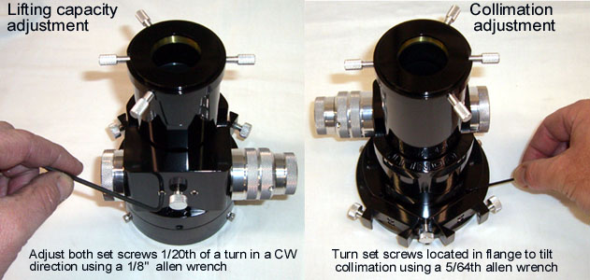

* 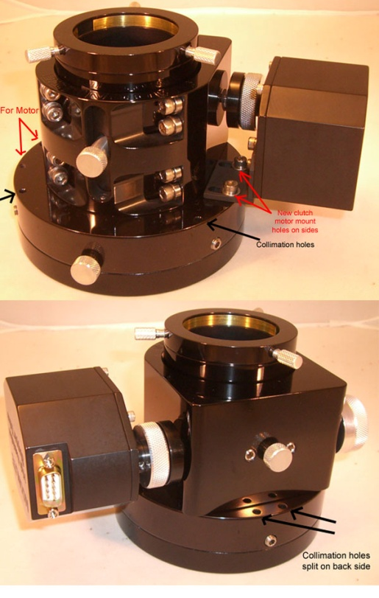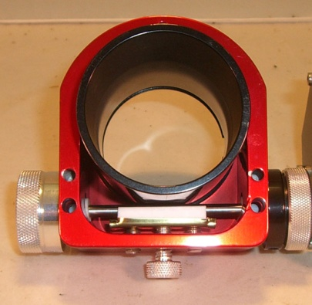**Lifting Capacity***:* The drawtube pressure can be adjusted to each user’s preference. Increasing the pressure increases the load capacity (vertical lifting capacity) of the focuser. Decreasing the pressure lowers the load capacity but gives the focuser a smoother focusing action. We set the focuser at approximately 5 lbs. at time of assembly; however, you can adjust it to be more depending on your specific needs. The ideal setting is to have it adjusted so the focuser can hold the heaviest load presented without slipping and requiring no additional force. This will give the focuser the best feel and still provide the vertical lifting capacity required. To adjust the lifting capacity, turn the aluminum thumbscrew located between the two setscrews on the bottom of the focuser clockwise (CW) to increase load capacity. The aluminum thumbscrew can only add pressure, not take away pressure. This is due to the 2 setscrews on each side of the thumbscrew applying a minimum set pressure amount. In some rare case it may be necessary to do a coarse adjustment by turning the 2 setscrews located on each side of the aluminum thumbscrew (1/8 Allen wrench is needed) a very small amount. Normally, 1/20th of a turn or less should be made on the setscrews in a CW direction, then check the lifting capacity pressure by racking the drawtube up and down with your heaviest load. **Note: excessive pressure adjustment over 1/20th of a turn can crack the bearings!**
* **Collimation**: To adjust collimation, turn the 4 mini setscrews located in the top part of the 2-part flange. A small amount of tip/tilt (.015 max) can be made by adjusting the 4 setscrews. We check collimation on each focusers before shipping so no adjustment should be required; however, if collimation is required due to some sort of problem when the focuser is installed, then the tip/tilt ability of the focuser's flange will come in handy. The rule of thumb is that less than 1 degree of tip/tilt error is tolerated by modern EPs. Use a 5/64th Allen wrench down in the set screw access holes to adjust the tip/ tilt of the upper flange to the lower flange. The set screws are nylon tipped and can prey the upper flange away from the lower flange making a small gap between the 2 flanges. Please note the set screws are roughly positioned in a 3 point fashion, but the rear back side position is split in to 2 set screws side by side to avoid an existing mounting set screw located at that location. Collimation holes are indicated in black on the photos.
* **Performance**: To maintain the CF focusers performance, keep all bearing and shaft riding surfaces clean on the drawtube. All Crayford style focusers require a clean bearing to drawtube surface for smooth operation. The drawtube has been polished to remove all machine marks and hard anodized resulting in the action having a super smooth feel. Keeping the surfaces clean will keep the focuser operating at optimal performance. Note: Some wear marks on the drawtube are normal over regular use and do not cause any performance issue; however, excessive wear marks on the drawtube can be seen if the drawtube is not clean. Airborne contaminates on the drawtube surface can get crushed between the bearings and the drawtube surface. The crushed particles will be abrasive causing the drawtube’s anodized surface to wear quicker than normal. Please keep the drawtube clean, especially in sandy/windy areas.
* **Reduction Unit**: Dual rate focuser owners may want to break in the 8:1 reduction unit by running it up and down when first receiving the focuser. It is adjusted fairly tight at the time of assembly and requires a little use to come up to peak performance. No maintenance should be required on the reduction unit as it is packed with lithium low temperature grease for the life of its operation.

**Motor Adjustments**

The amount of slip can be adjusted on the slip clutch by adjusting the tightness of the slip clutch ring. For manual knob operation of the focuser, turn the silver knurled ring loose. For motor operation of the focuser, tighten the silver knurled ring. To adjust the knurled rings tension, it helps to hold the manual knob still with your right hand and turn the clutch ring with your left hand. Holding the manual knob in place will keep the shaft from turning, allowing the clutch ring to tighten/loosen the clutch

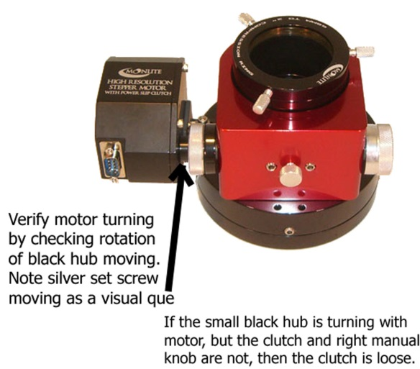**Focuser Adjustment Guide for Motor Options if Focuser Slips under Heavy Loads**

Slipping can be caused be either a loose clutch setting or drawtube to shaft pressure setting to low.

First-- check the slip clutch. Does the manual knob move when turning it by hand?

If it moves easily, then the clutch is loose. The manual knob should be very hard to move manually when the clutch is tight. Tighten up the clutch.

Second --- Check the drawtube tension (lifting capacity). Please be sure clutch is tight in above step, then check the drawtube to shaft tension by taking your hand and pushing on the drawtube to make it slip. The force needed to make the drawtube slip should be greater than your heaviest load used. If it slips easily, then increase the drawtube pressure (lifting capacity adjustment).

Visual inspection--

If the manual knob on the right does not turn when the focuser motor is running,( tighten clutch as shown in motor documentation). If the manual knob on the right is moving but the drawtube is not moving, then the drawtube is slipping and the shaft to drawtube pressure needs increased a small amount. See lifting capacity adjustment shown above.

To verify motor is moving in case of a cabling problem, check the black hub part of the clutch that is connected to the motor shaft for motion. If you look carefully at the black nub that attaches to the motor shaft, you may be able to see it turn as a small silver set screw should be noted turning around with the black hub. The black hub is on the left side of the slip clutch. The black larger pad side of the clutch is set screwed on to the main shaft. As the motor turns the small black hub part of the clutch will move with it. It is set screwed on to the motor shaft. This is a good way of testing to see if the motor is actually moving. The whole clutch as a unit should rotate with the motor if it is tight. If it is loose, then only the small hub on the motor side will be turning with the motor.

MoonLite Telescope Accessories, 755 Preserve Road, Danville PA 17821, 570-437-2232

www.focuser.com

Rev 02-15